Review Exercises 9.3 & 9.4 (5 points total) - p. 456

Note: For Review Exercise 9.4, How To 9.1 is on page 436.

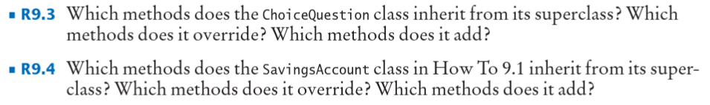

9.3:

Inherits: AddChoice

Overrides: Display

Adds:Arraylist Choices

9.4:

Inherits: Deposit, Withdraw

Overrides: Balance

Adds: Month end